Criw Cymraeg
What we do? / Beth ni yn wneud ?
As Criw Cymraeg, we are committed to promoting a Welsh ethos throughout Westwood Primary school by encouraging everyone to speak Welsh. The Criw Cymraeg (Welsh Crew) are instrumental in leading Welsh activities in school. Westwood’s goal is to fully achieve the ten targets within each award of the language charter.
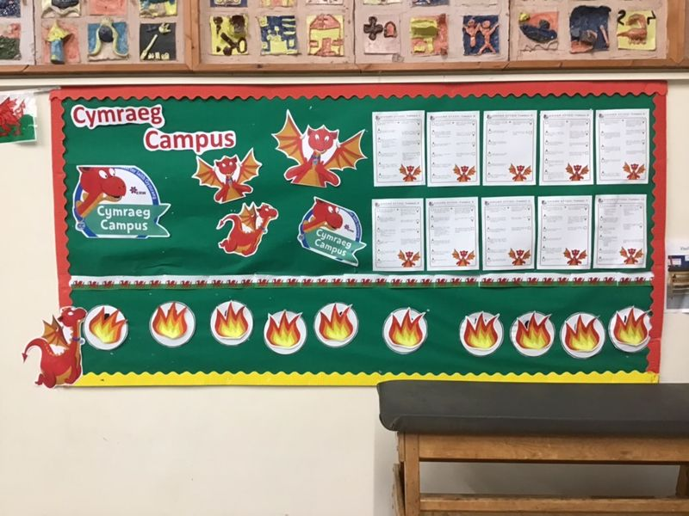
Language Charter
The Language Charter can be used to promote and increase the use of Welsh by children in a whole school context. In a nutshell, the Charter’s main aim is to promote a strong Welsh ethos in schools and to provide a range of enriching activities that propel the children to enjoy learning Welsh. The Language Charter exhorts participation from every member of the school community: members of the school workforce and council, the pupils and their parents, school governors and the wider community who are all encouraged to take full ownership of it.
Bronze, Silver and Gold Award
To ensure that all efforts are rewarded, the Charter is based on the principle that every school follows challenging but attainable targets in connection with promoting the use of the Welsh language. Westwood have achieved the Bronze award through many activities, and dedicated days to speaking Welsh.

- Diwrnod Darllen ac Iaith/ Welsh Reading and Oracy Day
- Dydd Arwr Cymru / Welsh Hero Day
- Criw Cymraeg’s Siop Cacen / Welsh Crew Cake Shop
- Eisteddfod
- Diwrnod Shwmae Su'mae

